Problem 1

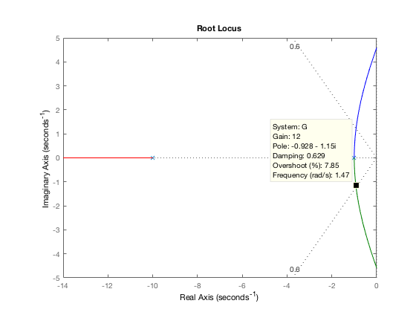

G = zpk([], [-1 -1 -10],1);

rlocus(G);

sgrid(0.6, 0);

axis([-14 0 -5 5])